Festivals/holidays

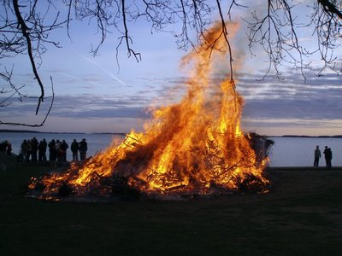 The Bonfire of Valborg

Match the holiday with the correct alternative

a) Sweden

b) Italy

c) Spain

d) Bulgaria

The correct alternative is: a.

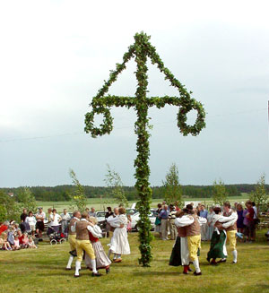 The Midsummer Pole

Match the holiday with the correct alternative

a) Italy

b) Sweden

c) Romania

d) Bulgaria

The correct alternative is: b.

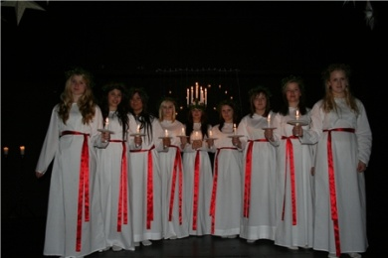 The celebration of Lucia

Match the celebration with the correct alternative

a) Sweden

b) Spain

c) Italy

d) Poland

The correct alternative is: a.

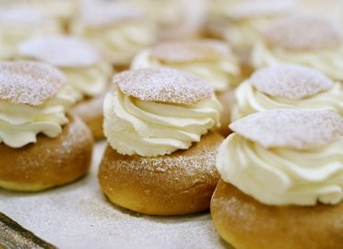 The day of the Semla

Match the celebration with the correct alternative

a) Turkey

b) Italy

c) Spain

d) Sweden

The correct alternative is: d.

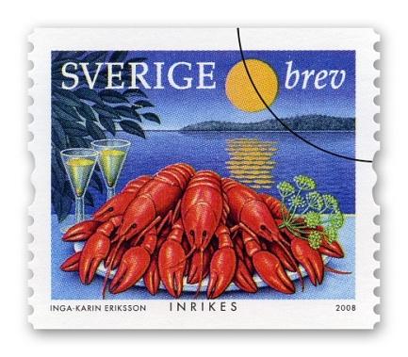 The crayfish party

Match the festival with the correct alternative

a) Sweden

b) Italy

c) Romania

d) Poland

The correct alternative is: a.